基隆市正濱國中110學年度第二學期英語科七年級補行評量題庫及答案
- 字彙測驗
- I always ______ the table before（在……之前）I put all the dishes（菜餚）on it.
(A) show (B) kill (C) set (D) believe
解答：(C)
詳解：由「在我擺放所有的菜餚在桌上之前」，可推知上句為「擺」碗筷。
- It’s my second ______ in the USA. Everything here is still new to me.
(A) market (B)river (C)factory (D)time
解答：(D)
詳解：由「這裡的一切對我而言還是很新鮮。」，可推知是說話者第二「次」到美國。
- The garbage truck（垃圾車）is coming in five minutes. Greg, go ______ the trash now.
(A) wake up (B)take out (C)go into (D)push around
解答：(B)
詳解：說話者提到垃圾車快到了，並要求Greg去「倒」垃圾。
- I ______ have dinner with my family at home. I eat dinner with them four times a week.
(A)always (B)never (C)seldom (D)usually
解答：(D)
詳解：由「一週有四天和家人吃晚餐」，可知「通常」會在家和家人吃晚餐。
- Don't believe in Simon. He ______ tells the truth(真相).
(A)always (B)often (C)usually (D)never
解答：(D)
詳解：由「不要相信」推知他「從不」說真話。
- There are many stands（攤販）at this ______. I want to get some food here.
(A)winter (B)city (C)dish (D)market
解答：(D)
詳解：由「我想要在這裡買些食物。」，可知這個「市場」有很多攤販。
- Jessie：Do you know the ______ to this math question?
Tina：No. Let’s ask Jason. He’s good at math.
(A)weather (B)answer (C)change (D)factory
解答：(D)
詳解：由「不知道。我們去問 Jason。」，可知 Jessie 在問數學問題的「答案」。
- In autumn, leaves（葉子）______ from green to red. They’re really beautiful.
(A) visit (B) buy (C)change (D)break
解答：(C)
詳解：由「在秋天，葉子從綠色……到紅色」，可推知為「改變」。
- A:The museum will close in an hour, but there are still many
______ outside.
B：Oh, they are from other cities and want to visit the
museum.
(A)visitors (B)fishermen (C)businessmen (D)germs
解答：(A)
詳解：由 come from other countries（來自其他國家）可知，在博物館仍有很多等待參觀的「訪客」，故選 (A)。
- Today is your birthday. Let’s eat out, and you can choose your favorite ______. It’s on me.
(A)street (B)restaurant (C)trash (D)following
解答：(B)
詳解：由「在外用餐」及「由我付錢」可知，是要對方挑選最喜愛的「餐廳」，故選 (B)。

- 文法測驗：
- Listen! The baby ______ in the bedroom. Why don’t you go in and take a look?【110教育會考】
(A)is crying (B)cry (C)cries (D)will cry
解答：(A)
詳解：關鍵字為 Listen!，要人傾聽，表示事情「現在正在進行」。
- Roy：______ do you go to the library?
Joe：Once a week.
(A)How (B)When (C)How often (D)How much
解答：(C)
詳解：詢問「頻率或次數」的疑問詞用 how often。
- Mr. Chen ______ on the school basketball team before.
(A) is (B)was (C)are (D)were
解答：(B)
詳解：由 before 可知時態為過去式，be 動詞的過去式為 was。
- My parents ______ doctors before. Now, my dad is a farmer, and my mom is a housewife.
(A)was (B)were (C)is (D)are
解答：(B)
詳解：由 before 可推知是在描述過去情況，主詞 my parents 為複數。
- A：______ do you go to the gym?
B：Never.
(A)How many (B)How many times
(C)How much (D)How often
解答：(D)
詳解：在詢問他人動作的頻率時，可用「How many times…?」或是「How often…?」。
- ______ rains a lot in Taipei in spring.
(A)The weather (B)It (C)We (D)There
解答：(B)
詳解：rain 當動詞時，主詞要用 it。
- It seldom ______ here in Keelung in winter.
(A)snows (B)is snowy
(C)has snow (D)is lots of snow
解答：(A)
詳解：主詞是 It，動詞用 snows。頻率副詞 seldom 須放 snows 之前。
- ______ a lot of snow in New York City. It’s very cold there.
(A)It’s (B)It has (C)There’s (D)The weather is
解答：(C)
詳解：snow 當名詞時，主詞可用「There＋be 動詞」或「人＋have」。
- A: Your car ______ clean. Do you often wash it?
B: Yes, I do.
(A)is never (B)never is (C)is always (D)always is
解答：(C)
詳解：回應「是的，時常清洗」推論車子「一直」是乾淨的。
- A：______ was John three hours ago?
B：He was at Jason's place.
(A)When (B)What (C)Where (D)How
解答：(C)
詳解：回應「Jason的住所」推測原問句詢問「去處」。

- 對話與完成句子：
- Stacy：How many times a week do you watch TV?
Bill：______
(A)in my free time (B)Three hours a day
(C)Usually at 10p.m. (D)Once or twice a week
解答：(D)
詳解：詳解：問「一星期看幾次電視」，應回答一週看電視的「次數」。
- How’s the weather?
B：______
(A)The trip was great. (B)What about yours?
(C)It’s cool and cloudy. (D)Yes, I was in the mountains then.
解答：(C)
詳解：(A)、(B)、(D) 皆與「詢問天氣如何」衝突，故選 (C)。
- Sue：Do you mop the floor?
Oliver：Yes, I sometimes do.
Sue：______
Oliver：Once a week.
(A) Don’t you like the mop?
(B) When do you mop the floor?
(C) What time do you mop the floor?
(D) How often do you mop the floor?
解答：(C)
詳解：由 Oliver 回答「一星期一次」，可知 Sue 問「頻率」。
- A: ______
B: It’s warm and sunny. Let’s go to the park and play
baseball.
(A) Is there a lot of rain here?
(B) What are they doing in the park?
(C) What’s the weather like today?
(D) How was the weather yesterday?
解答：(C)
詳解：由回答「溫暖又放晴」可知對方問的是「天候」。
- It was warm and sunny this morning, but ______.
(A) it was hot last night
(B) it is always warm here
(C) it is cold and rainy now
(D) it was still cloudy in the evening
解答：(C)
詳解：前一句早上天候問暖多情，但but引導與前一句立場不一的內容，故選(C)。
- A：Jerry and Fred are good boys. They often share the
housework.
B：Really?
A：Yes, Jerry ______, and Fred takes out the trash.
(A)take a look (B)does the dishes
(C)breaks his habits (D)never cleans the table
解答：(B)
詳解：第一句稱讚兩兄弟都是好孩子，並分攤家事，因此推論下一句兩兄弟都在做家事，故選(A)。

- 克漏字選擇
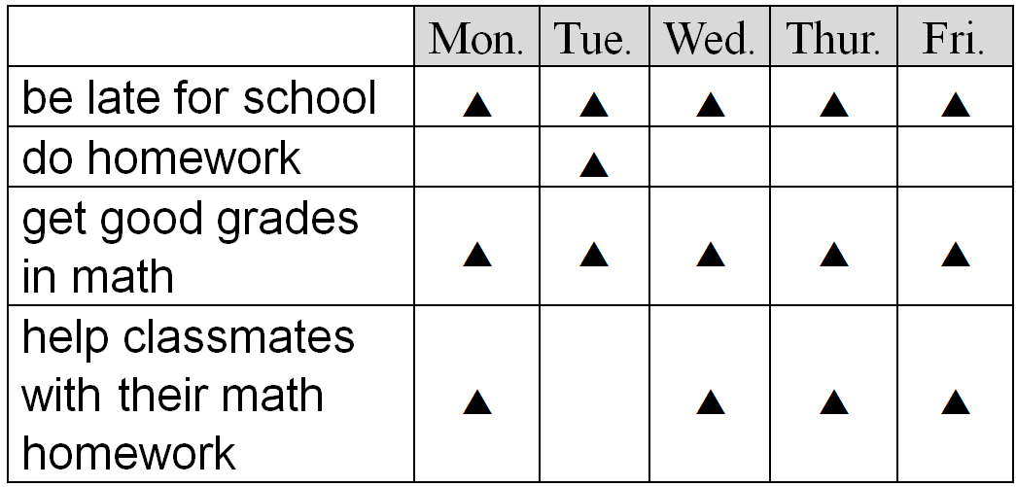
David is a junior high school student. He has some bad habits. __1.__ And he __2.__ does his homework. His teacher, Mrs. Lin, is sometimes angry with him. However, he is smart and can __3.__ get good grades in math. He even __4.__ helps his classmates with their math homework.
bad 不好的 angry 生氣的 however 然而

1. (A) He’s never late for school.
(B) He’s always late for school.
(C) He’s seldom late for school.
(D) He’s sometimes late for school.
2. (A) always (B) often (C) seldom (D) never
3. (A) always (B) usually (C) seldom (D) never
4. (A) always (B) often (C) seldom (D) never
解答：(B) (C) (A) (B)
詳解：
1. 根據表格，David「總是」遲到。
2. 根據表格，David「很少」做作業。
3. 根據表格，David 在數學「總是」能得到好成績。
4. 根據表格，David「時常」幫助同學解決數學問題。

Tanya：Hey, __1.__ you William Chan?
William：Yes, I am. Who’s this?
Tanya：It’s Tanya! We __2.__ neighbors ten years ago.
William：Oh, now I remember!
Tanya：It’s so nice to see you. How are you?
William：Not bad. I teach art in a high school.
Tanya：That’s great!
William：__3.__ You were really good at English before as I remember.
Tanya：But I’m not an English teacher.
William：What’s your job?
Tanya：__4.__
William：Wow. I can’t believe it!
neighbor鄰居 remember 記得 art 美術 as 如同 job 職業
1. (A) are (B) can (C) do (D) were
2. (A) is (B) are (C) were (D) was
3. (A) Is that great? (B) What about you?
(C) Don’t you like art? (D) Is that an art school?
4. (A) I wasn’t a teacher. (B) I was a nurse, then.
(C) No, my English is bad. (D) I’m a cook now.
解答：(A) (C) (B) (D)
詳解：
詳解：1. 詢問對方現在的身分需使用現在式 be 動詞。
2. 由「十年前」可知必須使用過去式 be 動詞，而 we 需搭配 were。
3. 由 William 講到他在高中教美術，Tanya 覺得很棒，可推知 William 會問 Tanya「那你呢？」。
4. 由 William 詢問 Tanya 目前的職業，可推知她會回答「我現在是一位廚師」。

- 閱讀測驗：
I live in Kaohsiung. Love River is a famous river in Kaohsiung. Fifteen years ago, Love River was dirty, and there was a lot of trash in it. Now, Love River is different. It is clean and beautiful. There are parks and coffee shops along the river. I can take a walk or have a cup of coffee there. There are also boat trips on the river. People can enjoy the beauty of the river on the boat.
live 居住 famous 有名的 coffee shop 咖啡店 boat 船 beauty 美
1. What does “it” mean?
(A) The boat. (B) Love river. (C) Kaohsiung. (D) The coffee shop.
2. How’s Love River now?
(A) It was very dirty.
(B) It is clean and beautiful.
(C) There was no trash in the river.
(D) People can take a walk on the river.
3. Which is true?
(A) Love River is dirty now.
(B) There are schools along the river.
(C) You can have a boat trip on Love River.
(D) People can’t take a walk or have a cup of coffee along the river.
解答：(B) (B) (C)
詳解：
1. 由該句前半段可知是在描述愛河。
2. 由第五句跟最後一句可知，愛河現在很乾淨，景色也很美麗。
3. 由倒數第二句可知，愛河上有很多船，人們可以坐船遊愛河。
weekly 每週的
hang out 和……出去玩

1. How often does Jake watch TV after dinner?
(A) He never watches TV after dinner.
(B) He always watches TV after dinner.
(C) He sometimes watches TV after dinner.
(D) He watches TV after dinner five days a week.
2. How often does Jake go swimming?
(A) Once a week.
(B) Twice a week.
(C) Three times a week.
(D) He goes swimming every day.
3. Today is Wednesday. Where was Jake yesterday at 8 p.m.?
(A) He was at home.
(B) He was at the guitar class.
(C) He was at his friend’s house.
(D) He was at the swimming pool. swimming pool 游泳池
解答：1. B 2. B 3. A
詳解：
1. 綜合表一及表二可知，Jake 每天晚餐後都會看電視，故選 (B)。
2. 由表二得知，Jake 每週末都會去游泳，因此每週共游泳兩次，選 (B)。
3. 題目表示今日若為週三，昨日週二依照行程表 Jake 是在家玩電動遊戲，故選 (A)。

